TezTournament

Prannvat Singh, Adil Hashlamon, Hamzah Mohamed, Subeen Regmi

Creators’ Note

[The future of E-Sports tournaments]

Table of Contents

Abstract………………………………………………………………………………..3

Background……………………………………………………………………………4

Proposed Product………………………………………………………………………4

Tezos Blockchain……………………………………………………………………...5

Validators………………………………………………………………………………6

Proof of concept……………………………………………………………………….7

Further Improvements and Feasibility………………………………………………...9

Additional features…………………………………………………………………….9

Conclusion……………………………………………………………………………..9

References……………………………………………………………………………10

Abstract

Gaming tournaments enable players to display their skills and compete for money. This means that gaming companies are constantly hosting tournaments for the best players. However, the centralised infrastructure that is traditionally used in the escrow systems of these tournaments have penetrable security. The transparency and anonymity are missing in these systems; to resolve this, we present TezTournament, a decentralised and secure way of awarding E-Sports gamers with prizes. We intend on utilising the potential of the Tezos blockchain to allow for a fair, and decentralised platform, on which transactions can take place securely and quickly, using smart contracts.

TezTournament

# [Background]

The gaming world has countless scams on a regular basis, some bigger than others. Scams involving escrow systems lead to players losing all their in-game inventory, or even losing real world currencies due to being misled by fake digital escrows1. Steam – a major games platform – was introduced with the Valve Escrow System2, which meant trades would be delayed, thus Steam would be able to detect any malicious activity. However, this is not completely safe as sometimes, scams can’t be detected and that has led to people getting hackedand losing inventory in games. TezTournament will tackle these problems and make a completely secure escrow system which will provide a platform for big E-Sports tournaments.

## [Proposed Product]

We propose a decentralised escrow system using the Tezos blockchain to secure transactions and remove the room for any room for foul-play. With TezTournament, gaming tournaments will be completely transparent and will have an impenetrable system, through which players will buy their ticket to enter a tournament for a set price in Tez, and this money will be pooled, until the smart contract is executed through which prizes will be awarded. The use of a blockchain and a decentralised system also allows for a unique identity for all players, yet complete anonymity as there are no inherent links between a crypto wallet address and any personal information. This means there will also be no room for impersonations and hacking of games to take place. As there will be no central ownership of the escrow system, players can also be assured that there is no way for anyone to collect data about them. The players contribute to the platform through the Tezos gas fees which will be there as they enter a tournament and buy a ticket. This will be very cheap, yet as the numbers of players and tournaments will increase, our product will become a self-sustaining system through the help of our users – there will be clear costs and no hidden tricks.

**[Tezos Blockchain]**

The Tezos blockchain forms the foundation of TezTournament; an ideal escrow system, which will be futureproof and with updates built on user-centred designs. The decentralised nature of any blockchain and our product means that ultimately, the users will be able to decide what is best for the platform in the future, with changes and updates being determined by the people. The Tezos self-amendment protocol will allow future innovations to be seamlessly incorporated into the blockchain. This, as well as allowing the users to be a key influence on the platform, will also ensure the security of the system as it will be constantly updated to combat any potential threats. Our design allows gaming companies to hold grand E-Sports tournaments without the hassle of having to worry about the security. For players to enter gaming tournament, they will have to make a transaction through their unique smart wallet and buy a ticket – the price of the ticket being determined by the hosts. While this transaction is made by the players, a rather small gas fee of about 0.001 Tez3 will be incurred. We believe that this is a very small trade-off for what the platform provides. Furthermore, Tezos has faster block creation compared to the likes of Bitcoin, being ~ 10x faster, as well as being far more environmentally friendly because of the efficiency in its proof of stake mechanism.

**[Validators]**

What - apart from the complete peace of mind and security of our decentralised system - sets us apart from the rest? TezTournament is a system, which is compatible with centralised and decentralised games; meaning that we need a way of determining fairly, and correctly, which gamer is the winner. As the actual game and our platform will be separate as the escrow system is decentralised and it is not necessary that the game be decentralised too, we need a way of communicating the winners to the blockchain. Our solution to this is a validator system. Once the players have voted on the winner, if there are any disagreements, that is when the validators step in. Validators will be people; they can be anyone who puts a deposit in except the people participating in the tournament. They will be able to deposit any amount of Tez as they wish, the more they do, the further back in the line they are – meaning the more they stand to earn. Their job will be to validate tournament matches through a vote; this vote will be made via a transaction executed through a smart contract. In addition to this, validators will also have the job of validating their fellow validators, this will mean that there will be a line of validators, each of whom will not know what order they are in the line. Each validator will be given the same tournament match which they will check, if the previous validator was lying and then the next validator in line receives the sum of their own deposit and the deposit of the previous validator. This is to reward them fairly for the increased deposit they put in at the beginning. If a validator is lying or not is determined when one decision is matched by 5 consecutive validators. If everyone is seen to be telling the truth, they all get their deposits back and they are moved onto the next match.

[Proof of concept]

We have designs ready to be implemented onto the blockchain with appropriate development. TezTournament will be a user-friendly, appealing dApp. We aim to have an interactable and easy to surf user interface. These designs are made by us with the intention of enabling users to access easily and quickly, what they wish on our platform.

homePageLoggedOut

StorePage

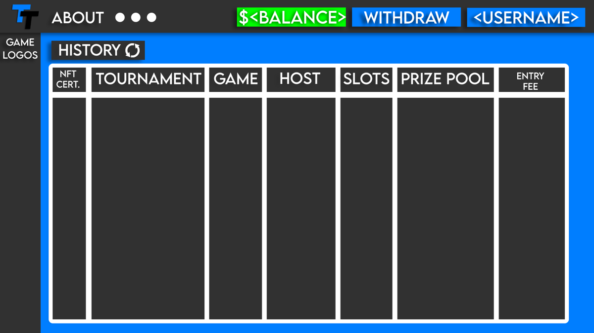

HomePageLoggedIn

In addition to our design, we needed to see if our system could truly work. Looking at previous attempts at digital escrow systems, we found that they were perfectly sound in what they did, however their security was very lacklustre. As mentioned briefly in [Background], these platforms work, however due to their centralised nature, there are too many vulnerabilities, which hackers can take advantage of. As we have mentioned beforehand our decentralised system eradicates the room for any of this kind of malicious activity. Every transaction, made by anyone, is all recorded on the blockchain, meaning nobody can get away with any kind of foul play.

[Further improvements and Feasibility]

The speed of our platform depends on the block creation rate of the Tezos blockchain. Considering our product, we believe that the current Tezos block creation rate is fast enough to run tournaments reliably and efficiently. TezTournament will be able to host an escrow system for several tournaments simultaneously and not let it affect the performance of the system.

[Additional features]

As well as being an escrow system, TezTournament will also provide a store for winners to purchase in-game items sold from a selection determined by Tezos. The winners will be able to choose how they wish to take out the Tez they have won, either having it transferred into their smart wallet, or buying in game items sold from a selection determined by Tezos. In addition to this, the winners will get NFT’s linked to the address of the tournament on the blockchain. Theis will also be transferred to the winners through their smart wallet. We aim to not only provide a secure, futureproof platform, but also build a relationship with our users.

[Conclusion]

The room for hacking and scams is too big and easy to access with current systems. Our sole aim is to provide a system which is impenetrable and works according to the user. TezTournament uses the validation system and the use of the blockchain and transaction through smart contracts to become as decentralised as possible and give the user a seamless experience.

References

1[https://blog.iamvouched.com/fraud-story-40-fake-digital-escrow-scam-in-gaming- ckrfiktnl385731zpfmxwzfi5a/](https://blog.iamvouched.com/fraud-story-40-fake-digital-escrow-scam-in-gaming-   ckrfiktnl385731zpfmxwzfi5a/)

2<https://www.helpnetsecurity.com/2015/12/11/new-steam-escrow-system-drives-impatient-users-to-fake-trading-sites-serving-malware/>

3 <https://walletinvestor.com/compare/tezos-vs-bitcoin>

